Lab Evaluation-1
Juturu Naga Abhinava Sai
CB.SC.U4CSE23563
5/2/2026
Total Marks : 50
60% weightage for earlier submission and 40% for todays evaluation
Note : Keep a separate word document for Lab 1 submission completed till yesterday
- About the Use case:
"Opposites Explorer" is an interactive educational web application designed specifically for children with Autism Spectrum Disorder (ASD). It facilitates the learning of antonyms through a sensory-friendly interface that combines high-contrast visuals, kinetic typography, and immediate audio feedback. The application features a 'Practice Mode' for low-stress exploration and a 'Quiz Mode' for assessment. Recent updates include a "Suggestion Module" that allows users to contribute new word pairs, making the platform extensible and community-driven.
- Upload the completed Lab 1 in github
https://github.com/abhinav-juturu/OppositesExplorer
- Extend the completed Lab1 exercise with following :
- Add one more webpage that can be a extended one related to the concept completed that has forms
- Refer https://www.tutorialspoint.com/reactjs/index.htm
All concepts including Hooks and routing

Complete the table below adding your contribution:

Concept | Code Proof/Screenshot
Function component | 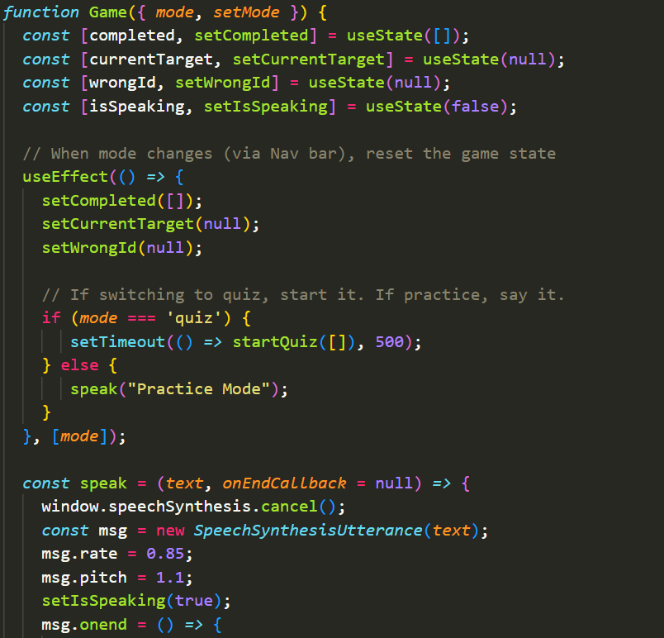
Class Component | 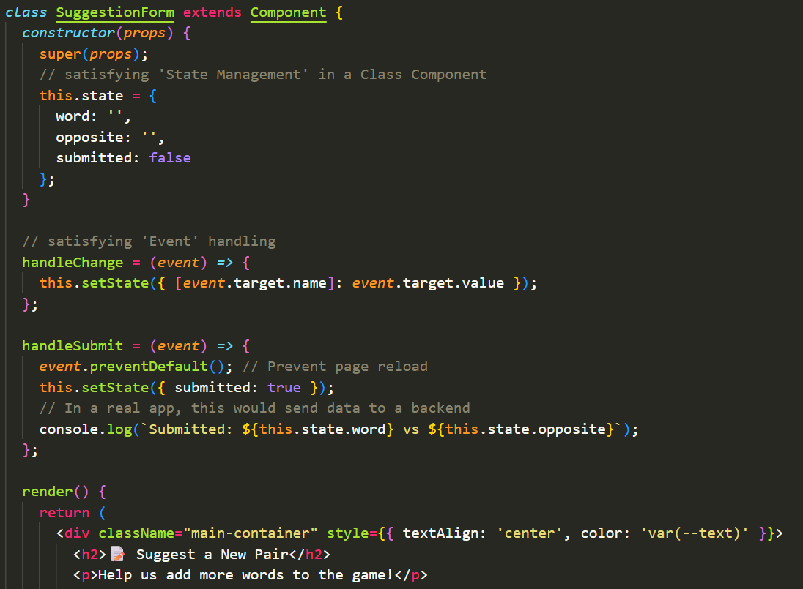
Event | 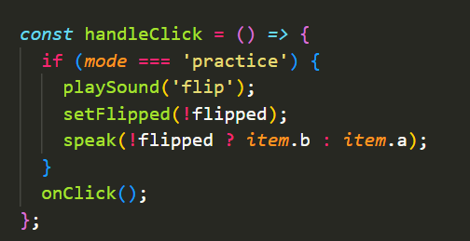  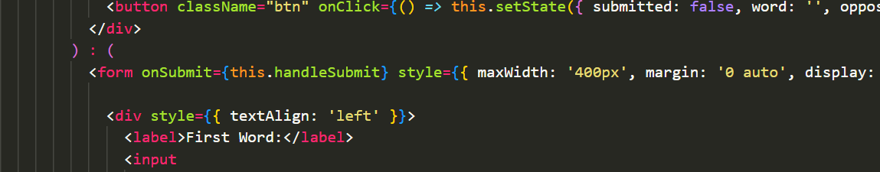
State Management | 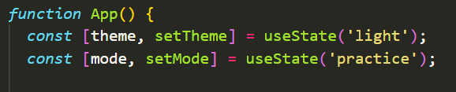  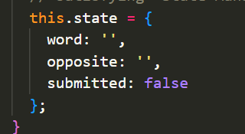
Stateless Component | 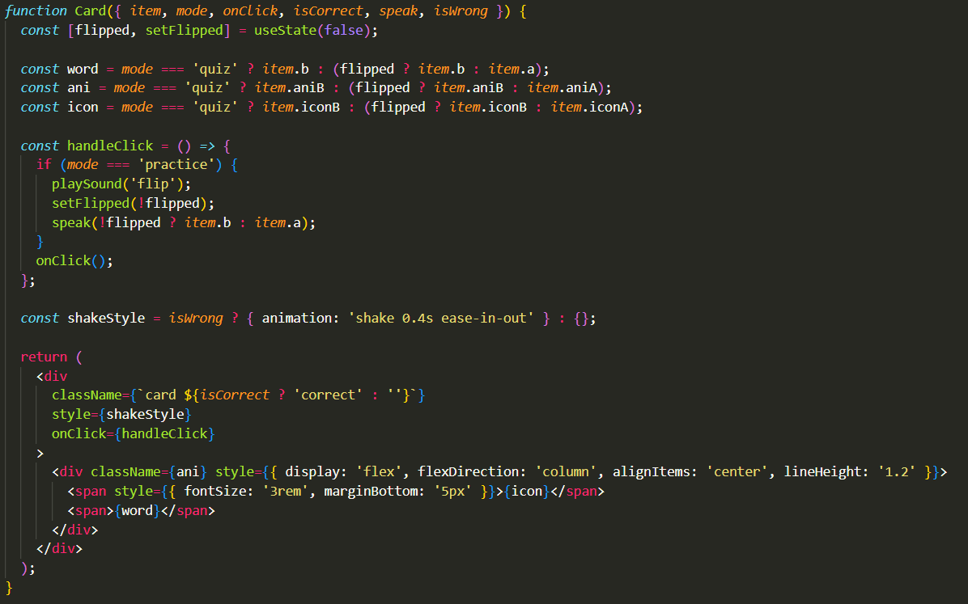
Forms | 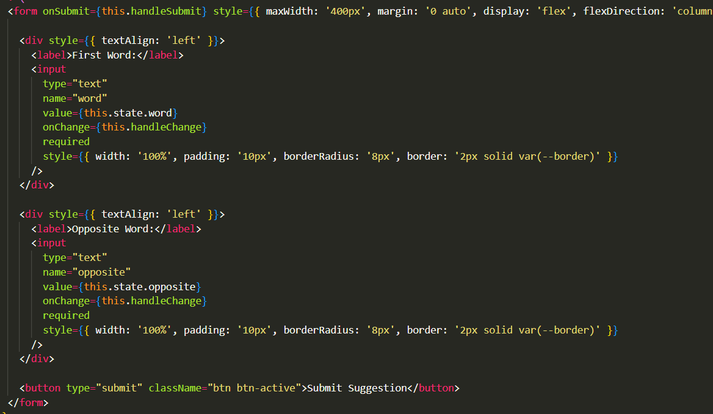
Routing | 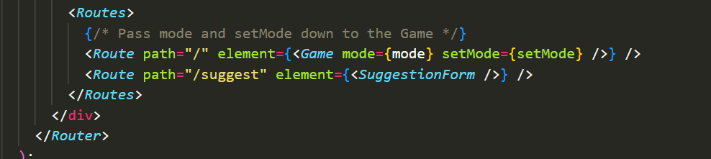
Hooks | 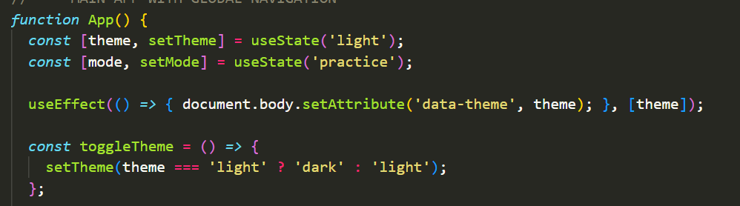

Forms Output:
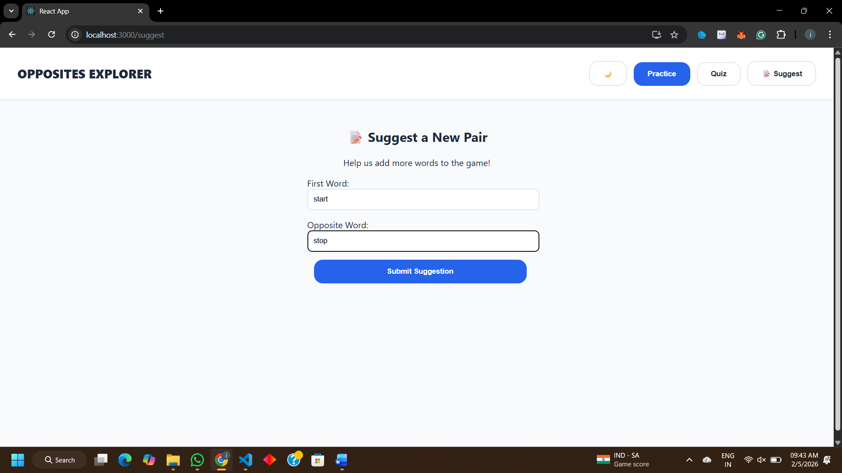
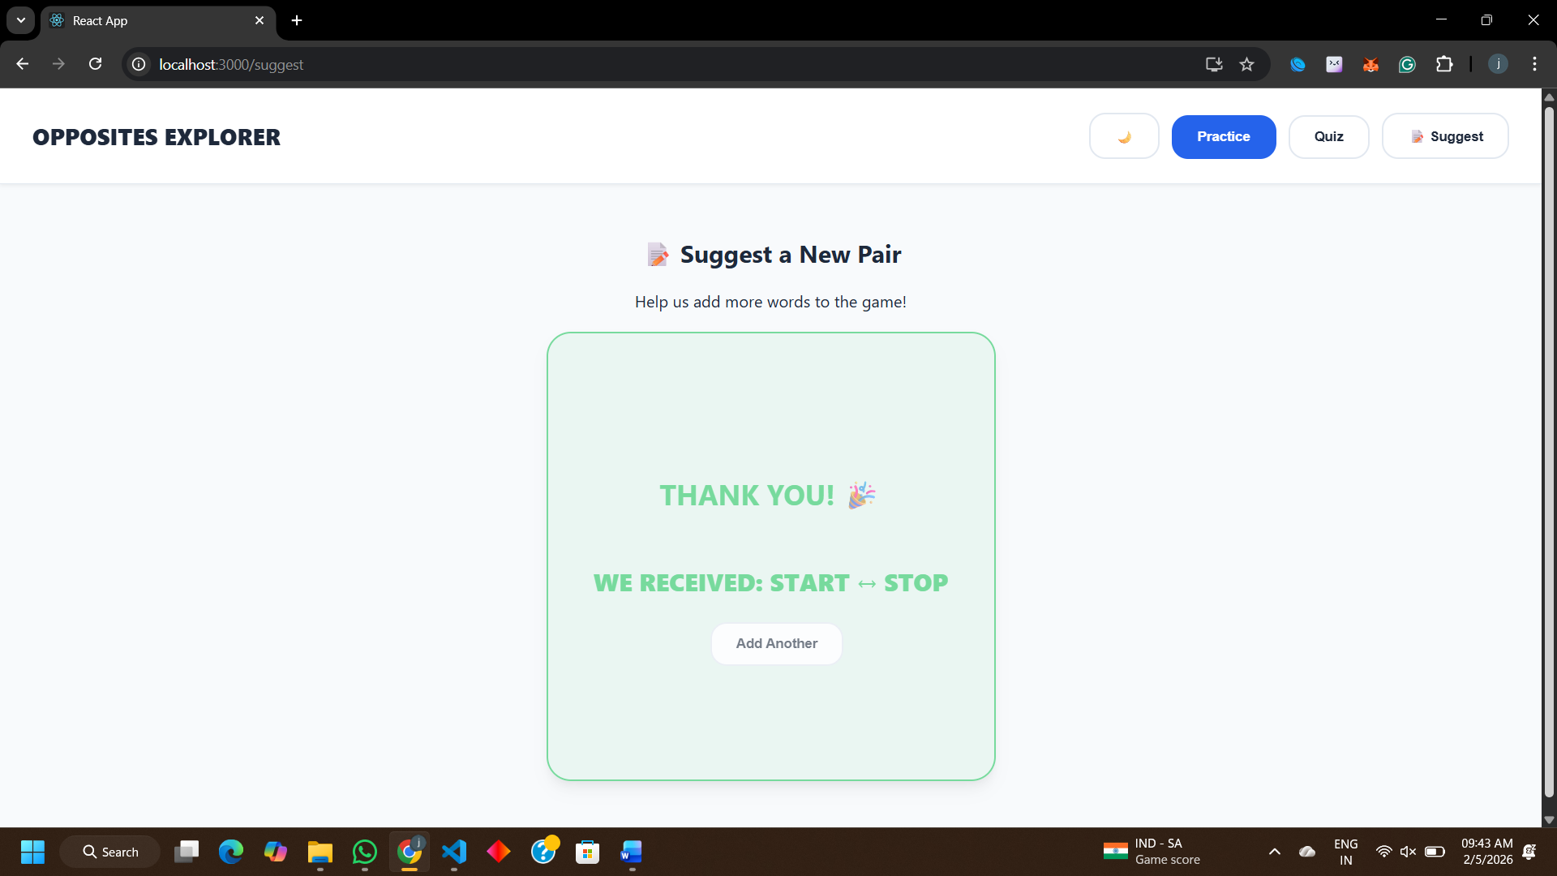

UI Aspects--- 10 Marks
Concepts Implemented from React JS---30 marks
Extension Level---10 Mark

